**Tools needs to be installed on your machine to learn DevOps**

**1.Java 21 : Download it from following URL:-**

[**https://www.oracle.com/in/java/technologies/downloads/#jdk21-windows**](https://www.oracle.com/in/java/technologies/downloads/#jdk21-windows)

Download and configure:

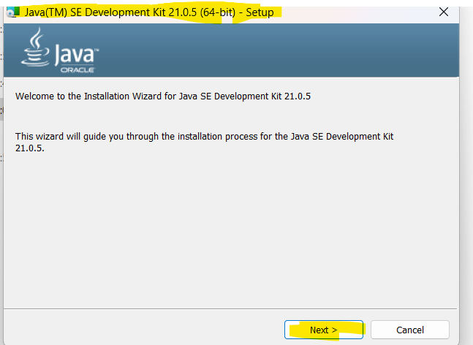

**2 . Git for windows: Download it from following URL:-**

[**https://git-scm.com/downloads/win**](https://git-scm.com/downloads/win)

Download and configure:

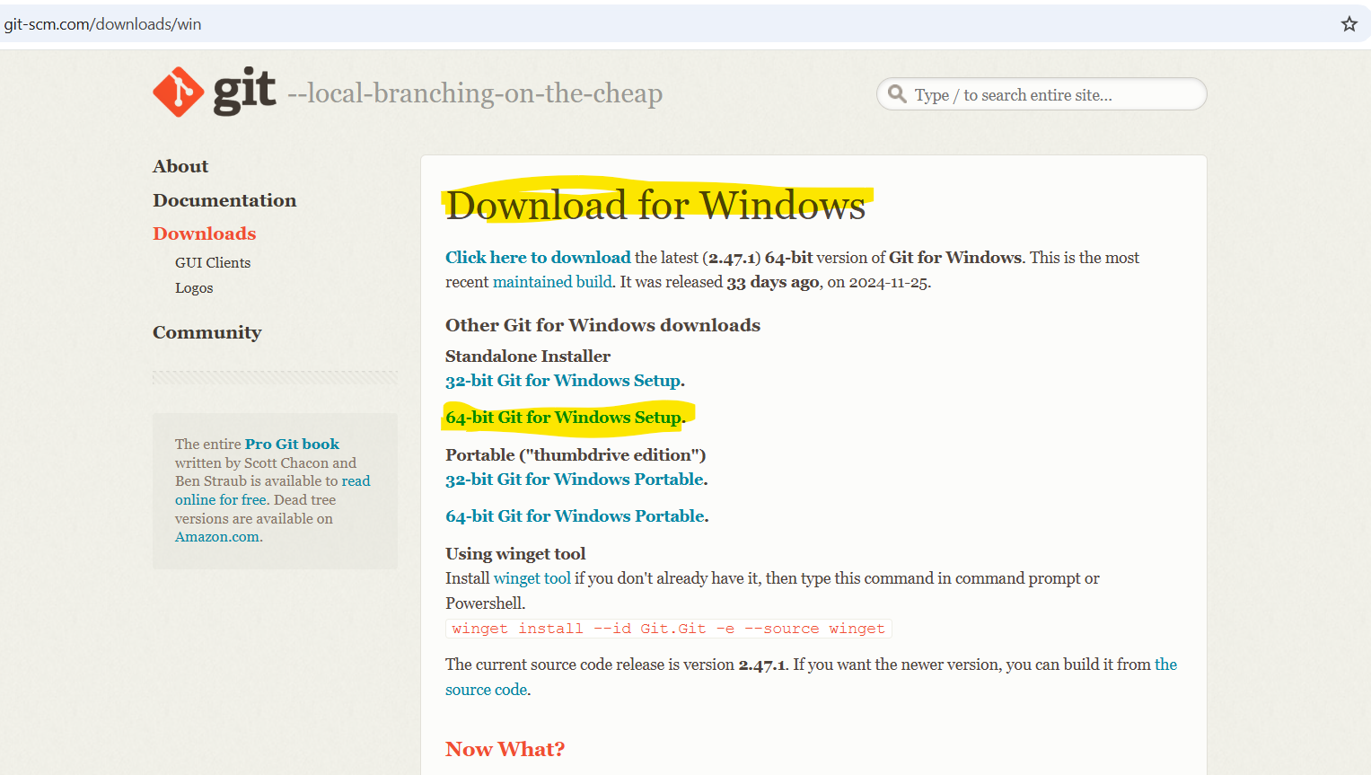

Click on next, Keep the default options and install git.

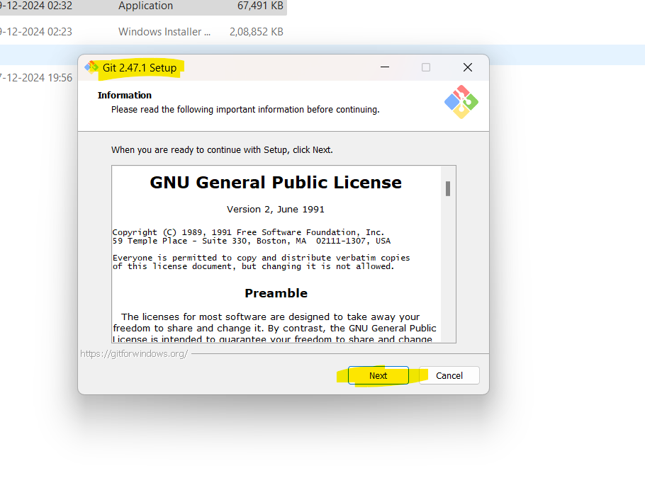

**3. Maven : Download it from following URL:-**

[**https://maven.apache.org/download.cgi**](https://maven.apache.org/download.cgi)

Download maven for windows from apache maven website and configure it.

Download Binary zip archive for windows.

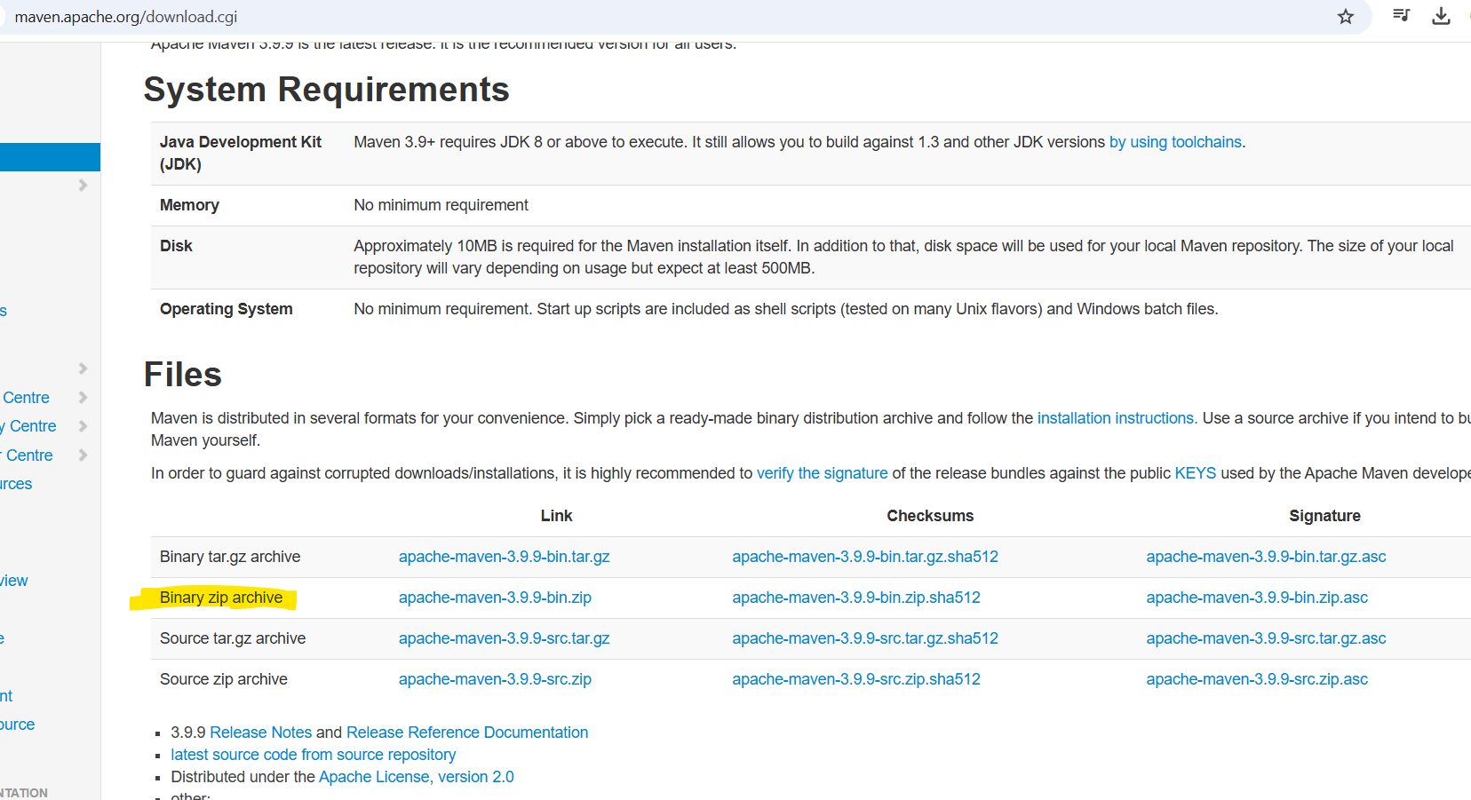

Zip file will be downloaded, you need to extract it once downloaded.

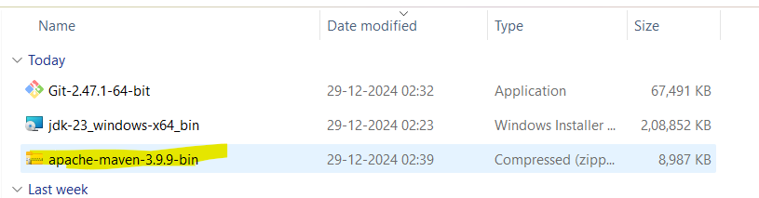

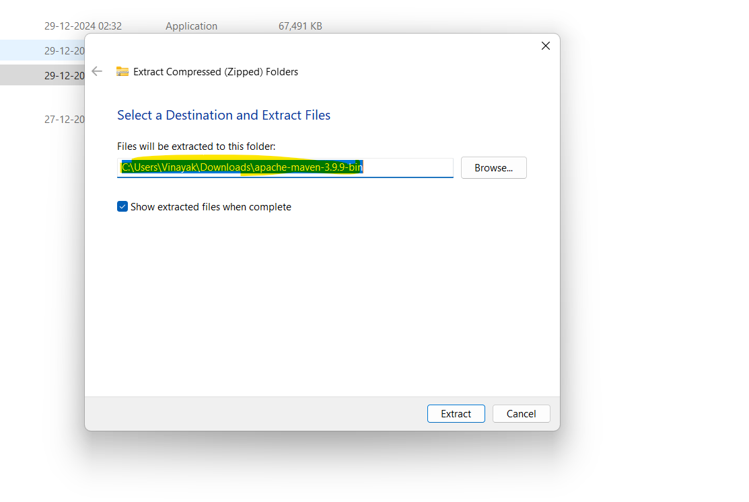

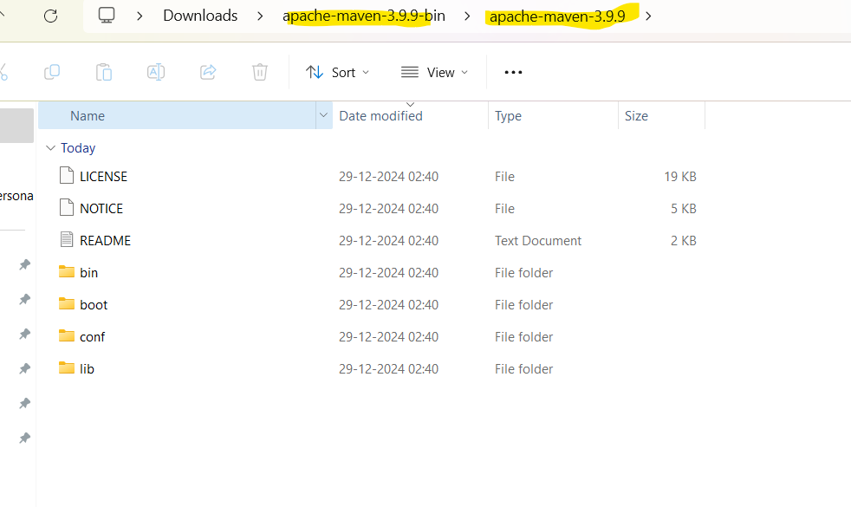

**4. Intellij Idea Community edition : Download it from following URL**:-

[**https://www.jetbrains.com/idea/download/?section=windows**](https://www.jetbrains.com/idea/download/?section=windows)

Download and install Intellij Idea Community edition from jetbranins website.

You need to download Community edition for windows, it’s a free.

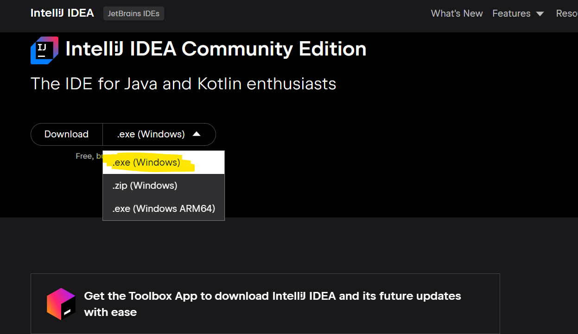

Click on next.

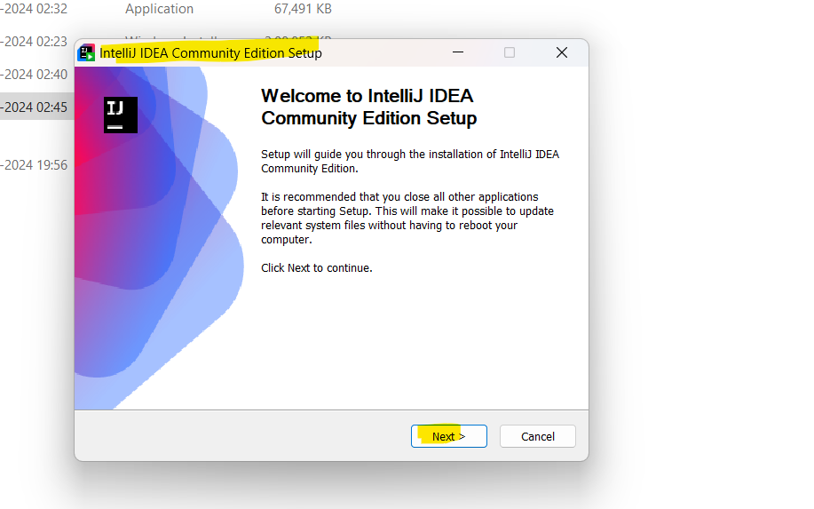

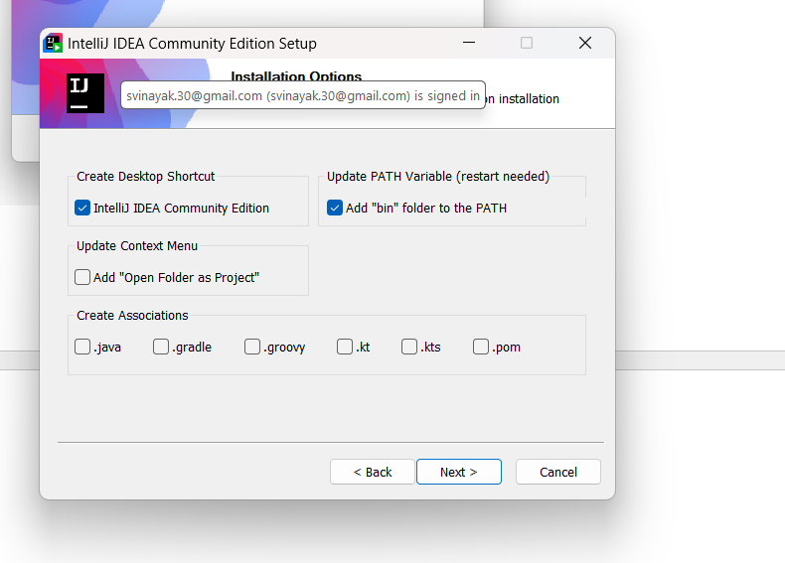

**5. Terraform : Download it from following URL:-**

[**https://developer.hashicorp.com/terraform/install**](https://developer.hashicorp.com/terraform/install)

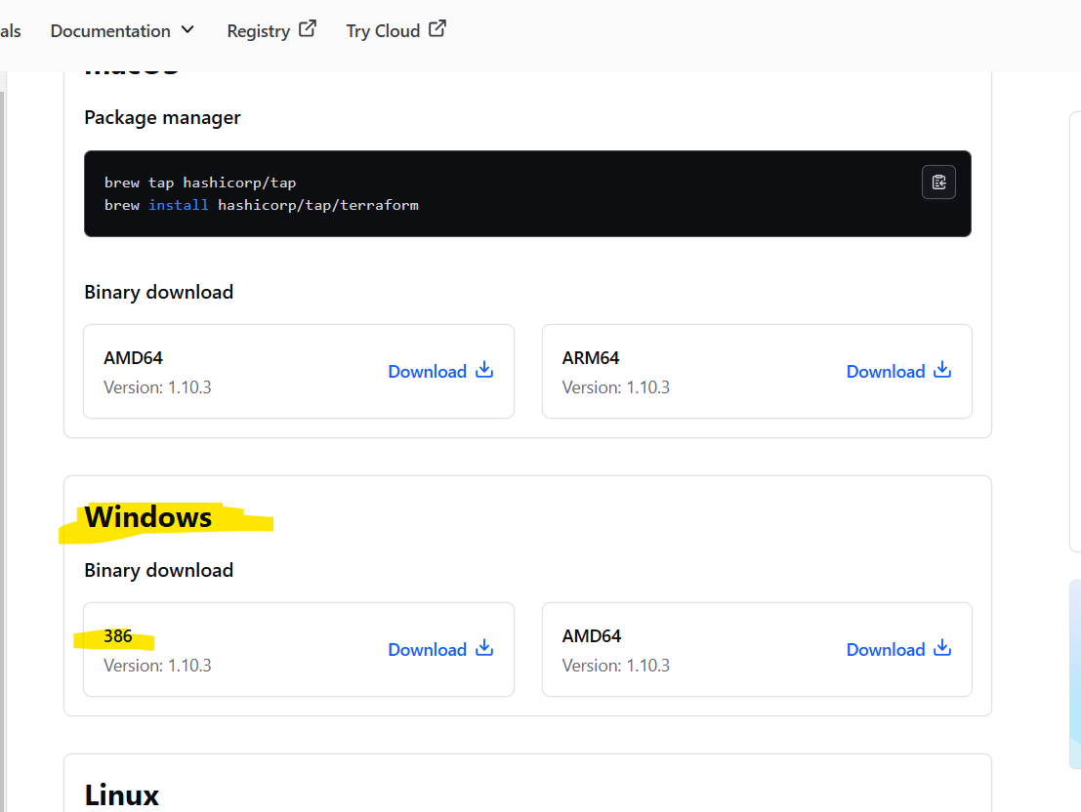

Once you downloaded Terraform, extract it.

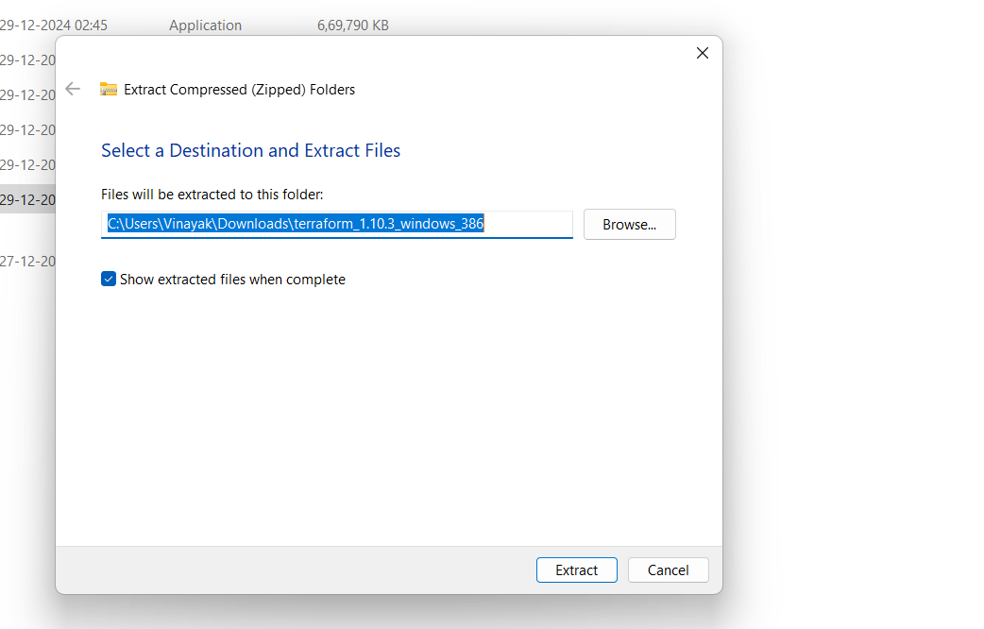

Double click on Terraform to install.

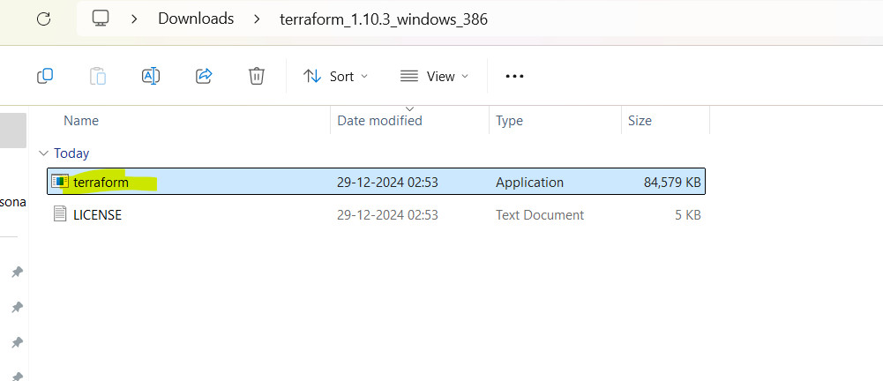

**NOTE**

**Once the installation is done, you need to set up the environment variable for some tools. Follow the steps below to set up the environment variable:**

1. Click on the Search button on your taskbar and type env.
2. Click on Edit the system environment variables.
3. Click on Environment Variables.

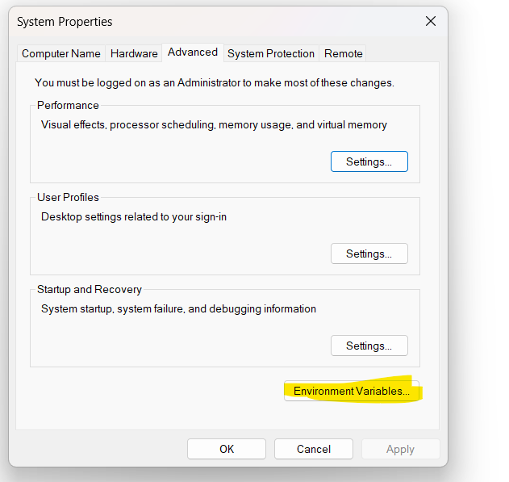

Under System Variable, Double Click on Path. 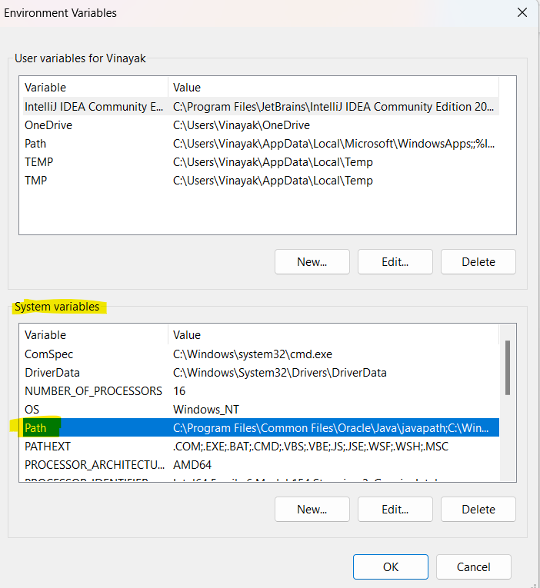

You need to configure path for some tools. 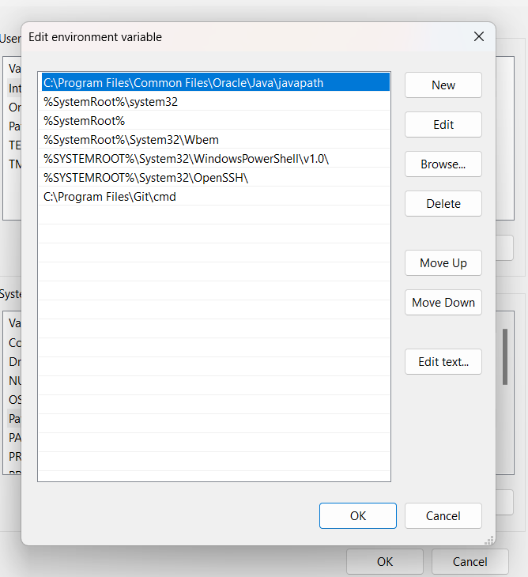

**Add Path below in Environment Variable:**

1. **Java :**

**C:\Program Files\Java\jdk-21\bin**

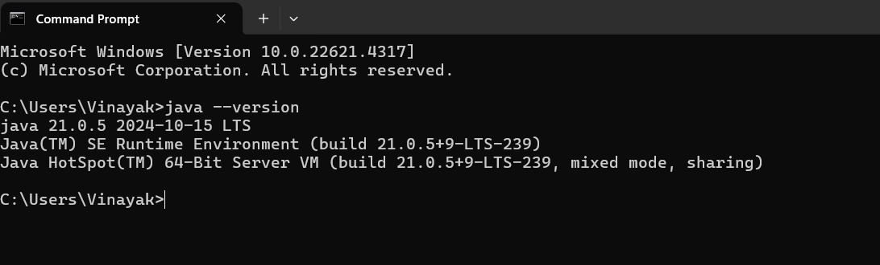

1. **Maven :**

**C:\Users\Vinayak\Downloads\apache-maven-3.9.9-bin\apache-maven-3.9.9\bin (ensure that you enter the correct directory path/User will be different)**

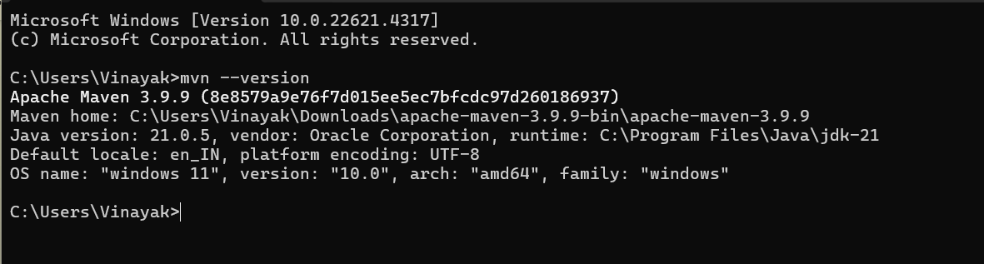

1. **Git :**

**C:\Program Files\Git\cmd**

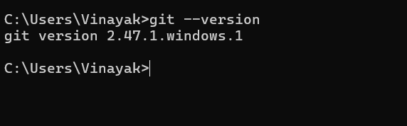

1. **Terraform :**

**C:\Users\Vinayak\Downloads\terraform_1.10.3_windows_386 (ensure that you enter the correct directory path/User will be different)**

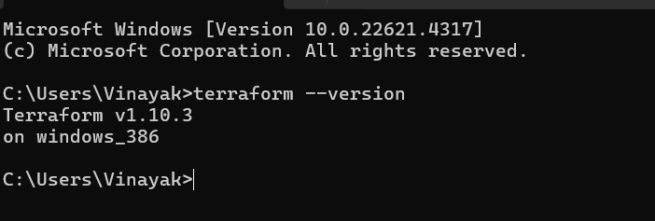

**6. GitHub Account :**

**You also need to create GitHub Account :**

Go to GitHub Website to create a GitHub Account.

[**https://github.com**](https://github.com)

Enter your Email Id and Click on Signup.

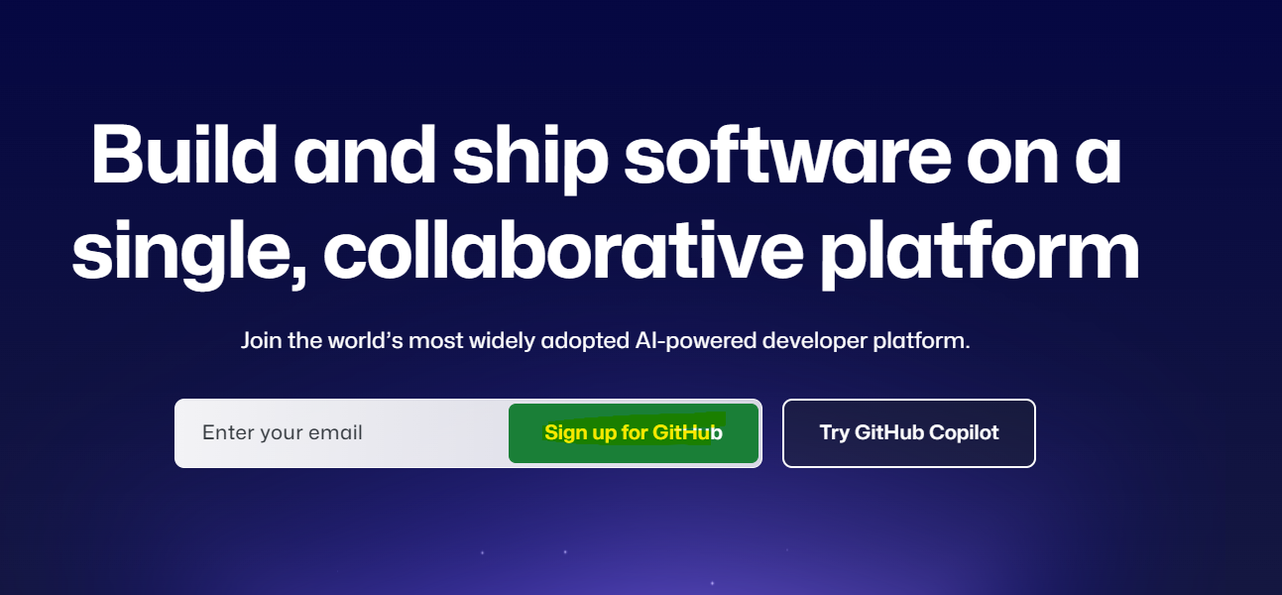

Provide Required details and create Account.

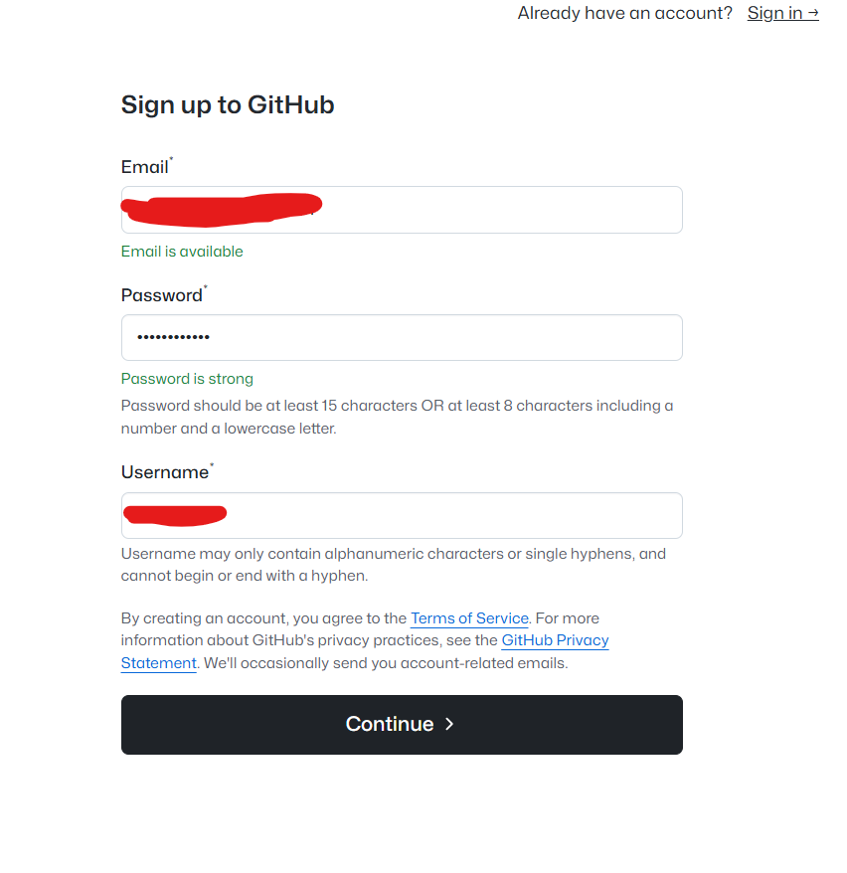

Once the account is created on GitHub, sign in to your account.

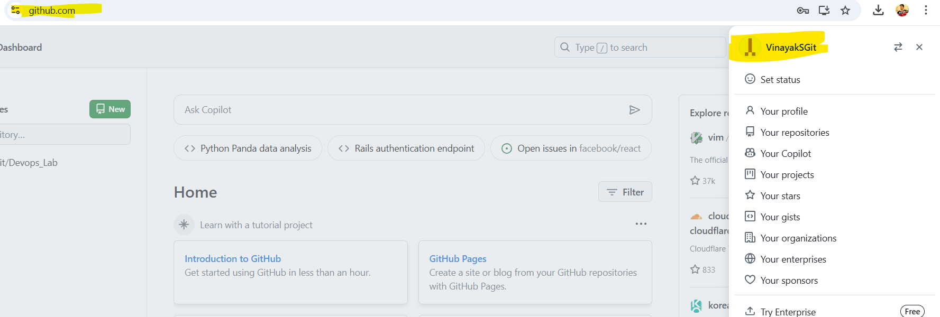

**7. AWS Free Tier Account :**

Go to AWS Website to create free tier Account.

[**https://signin.aws.amazon.com/signup?request_type=register**](https://signin.aws.amazon.com/signup?request_type=register)

Enter the required details and create AWS free tier Account.

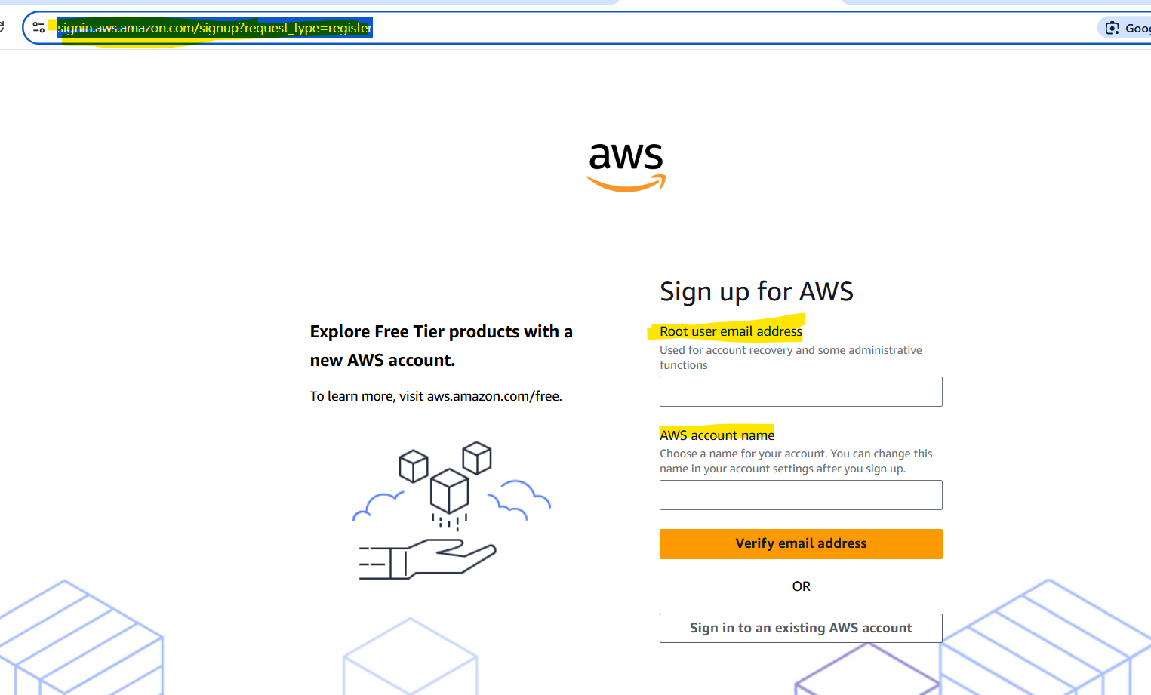

Once the account is created on AWS, sign in to your account.

